**Task1: Creating a bootstrap instance**Step1:In configure instance details under user data we have to put this script  
#!/bin/bash

yum -y install httpd

service httpd start

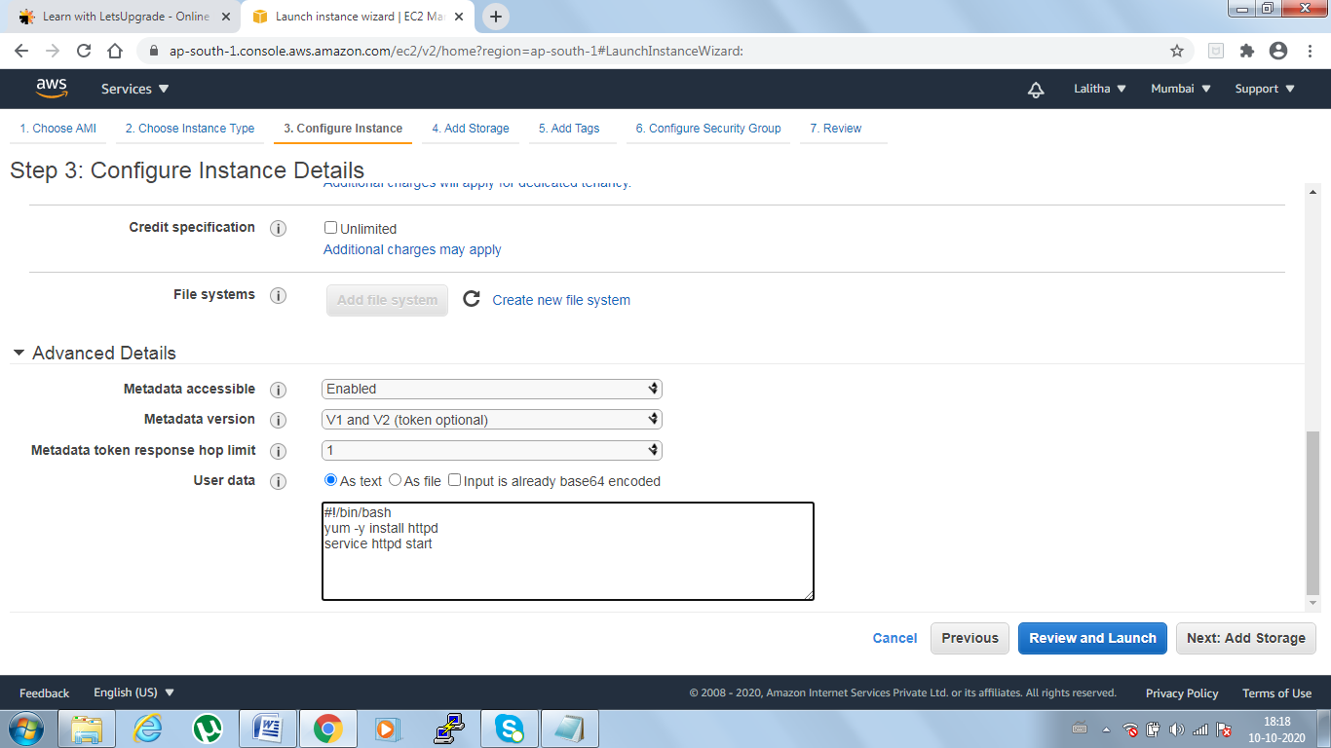

Step2: Create linux instance with above script and open the public IP in other window where you can see the Tomcat test page which means successful.

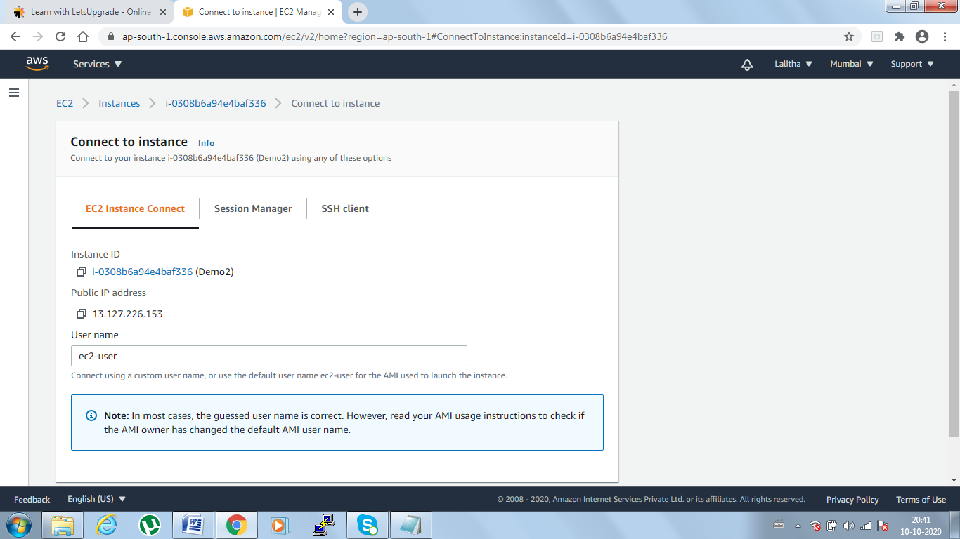

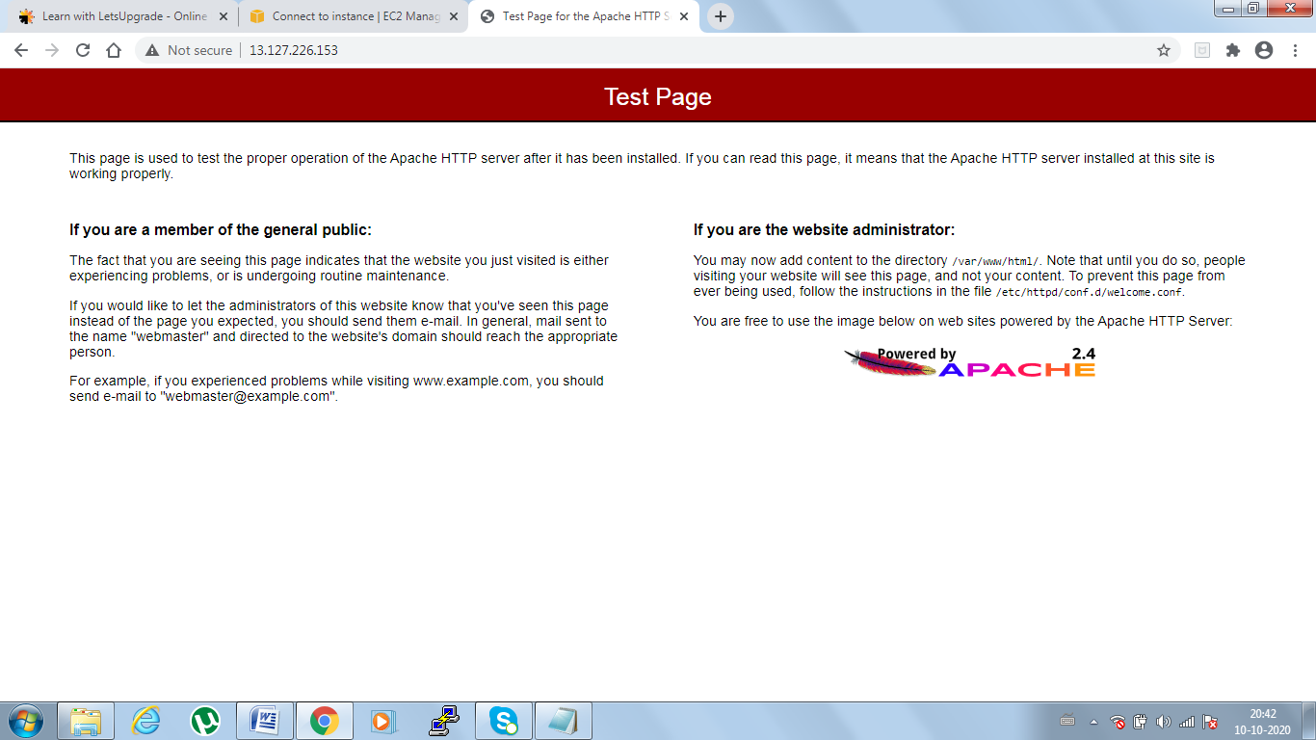

**Task2: Checking bucket list and creating a new bucket from EC2 using IAM roles**Step1: Creating an IAM role  
All services -> search IAM -> IAM Dashboard->Roles->Create Roles-> AWS Service ->Select EC2(Under choose an use case)->Click on permissions ->Under filter type S3 -> select AS3 full access (2nd option)-> Add tags -> Role name (s3-test-1)->create Role

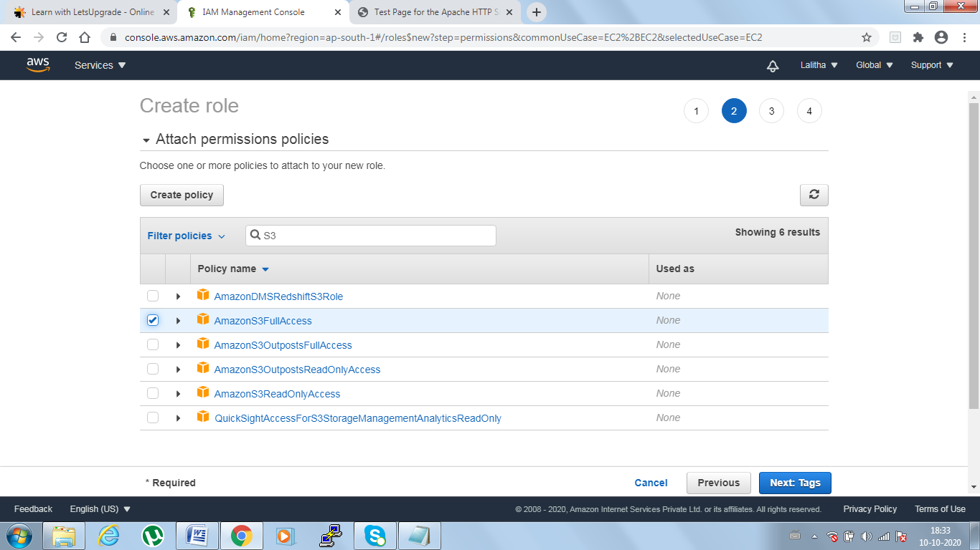

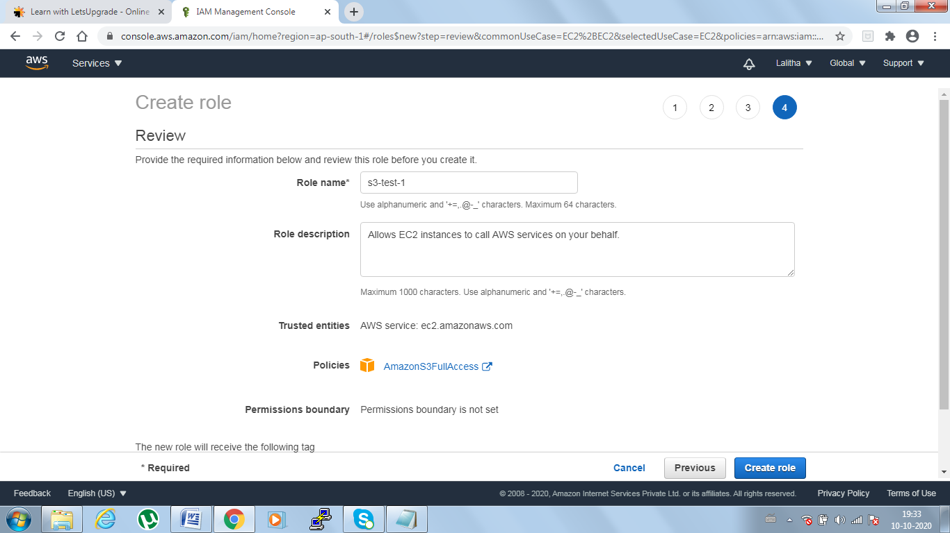

To modify IAM role Instance-> action->instance settings-> modify IAM role

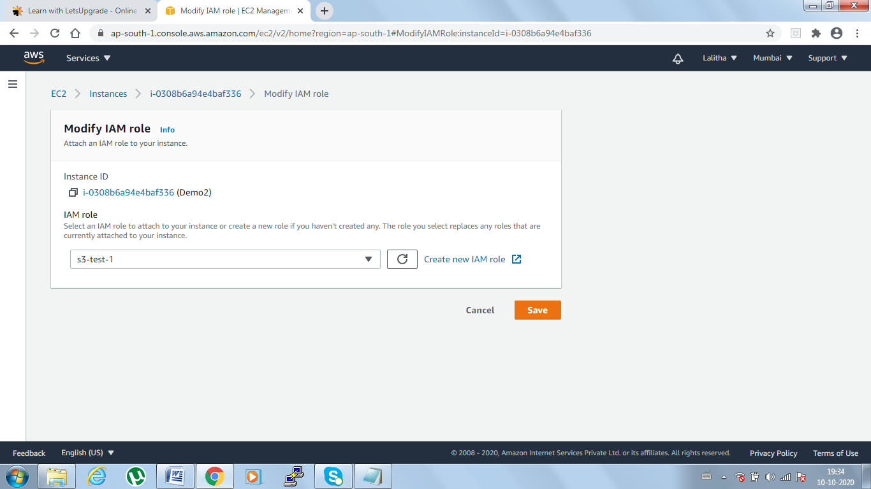

Step2: Connect to the instance in other window (here no need of putty)

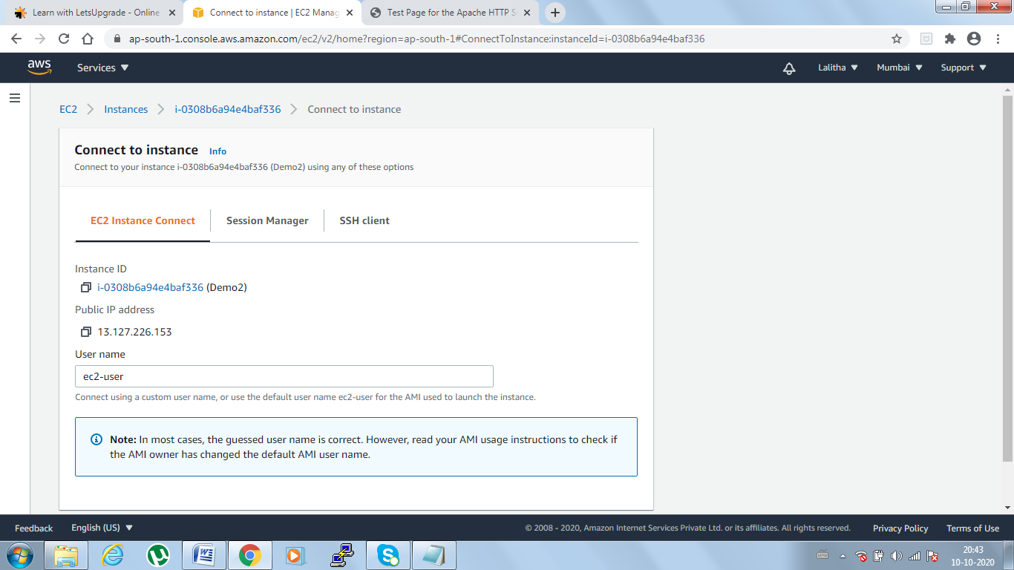

Step3: Execute the commands to display the list of buckets available and create new bucket

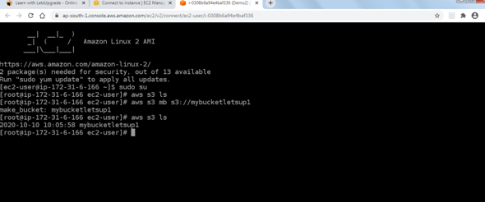

Step3: After executing the above scripts, check in your bucket whether any buckets created with mentioned name or not. If created success else some issue

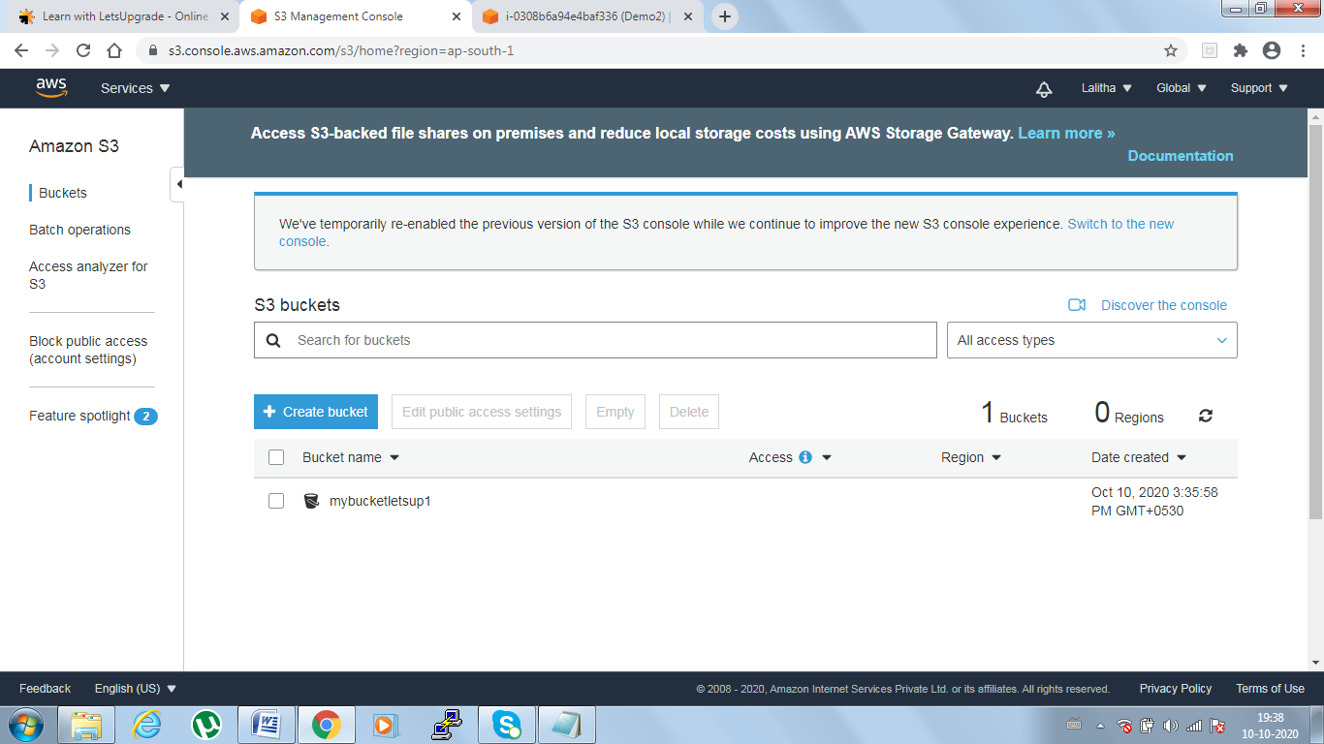

**Task3: Hosting a webpage using bootstarp script on ec2**

Step1 : Modify the user data in existing instance or create new instance with below commands passed in UserData section while creating instance

#!/bin/bash

yum install httpd -y

aws s3 cp s3://s3-tester2/index.html /var/www/html

service httpd start

chkconfig httpd on

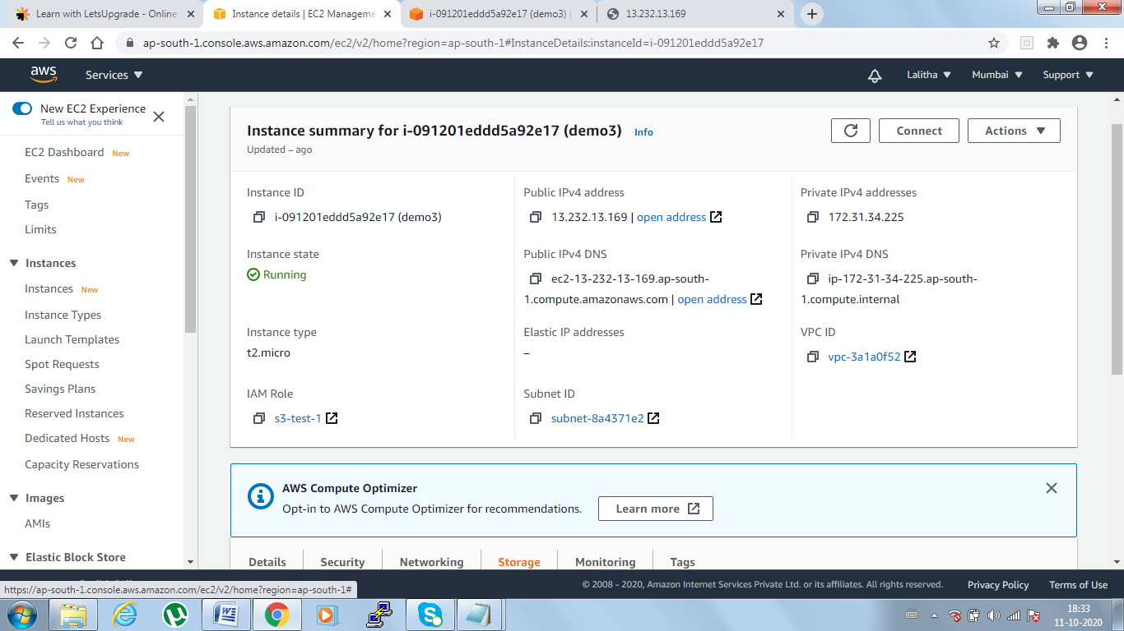

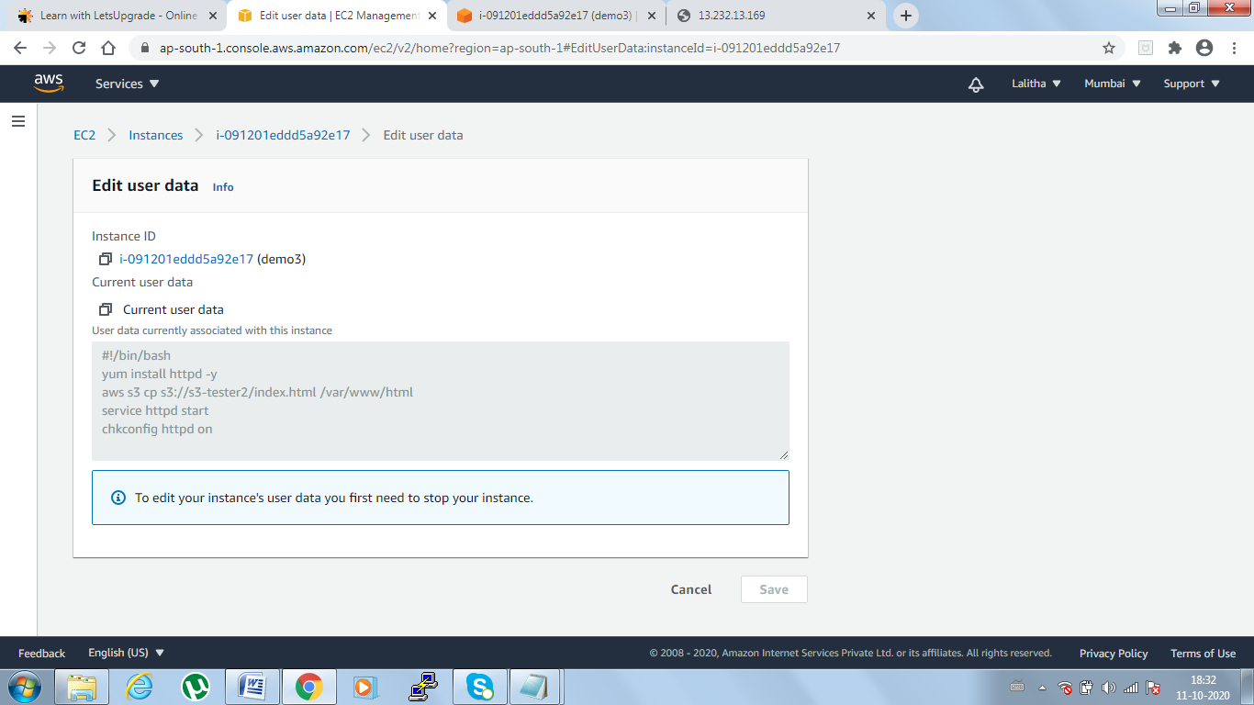

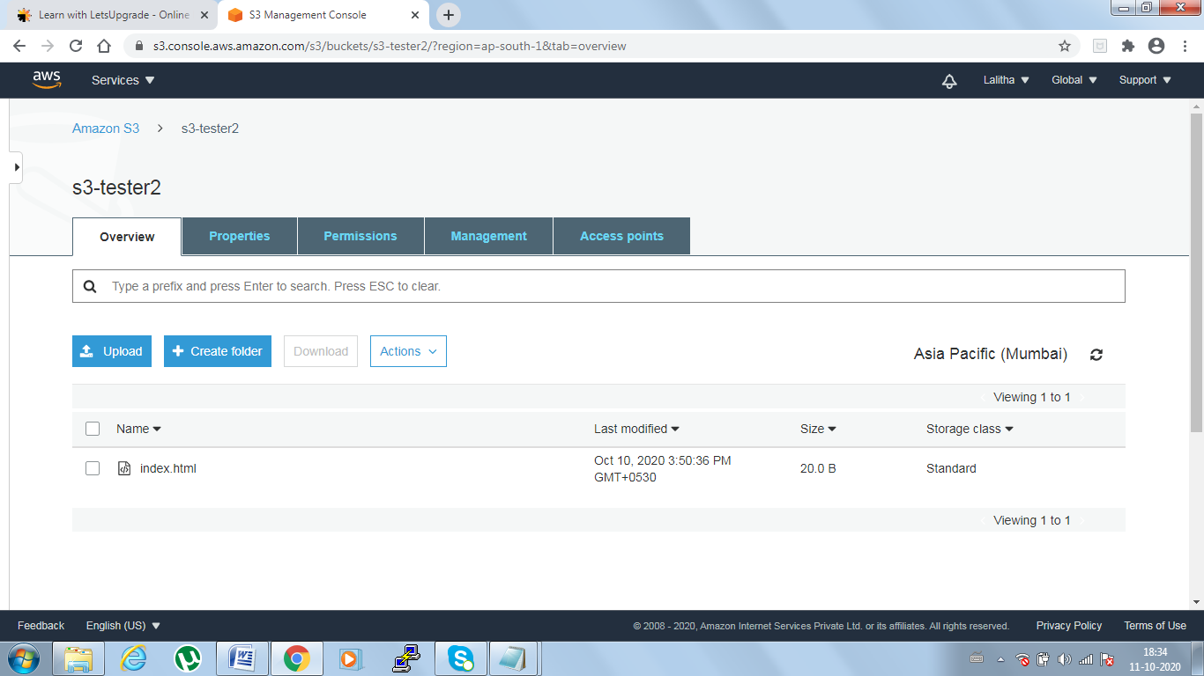



**DAY 6 Tasks**

**Task1:** Creating an instance in custom VPC   
AWS-> Services->VPC managment console ->Clk on Your VPC's->Create VPC

VPC Settings -> Name as demo vpc->IPAddress IPV4 (172.19.0.0/16)-> Create VPC

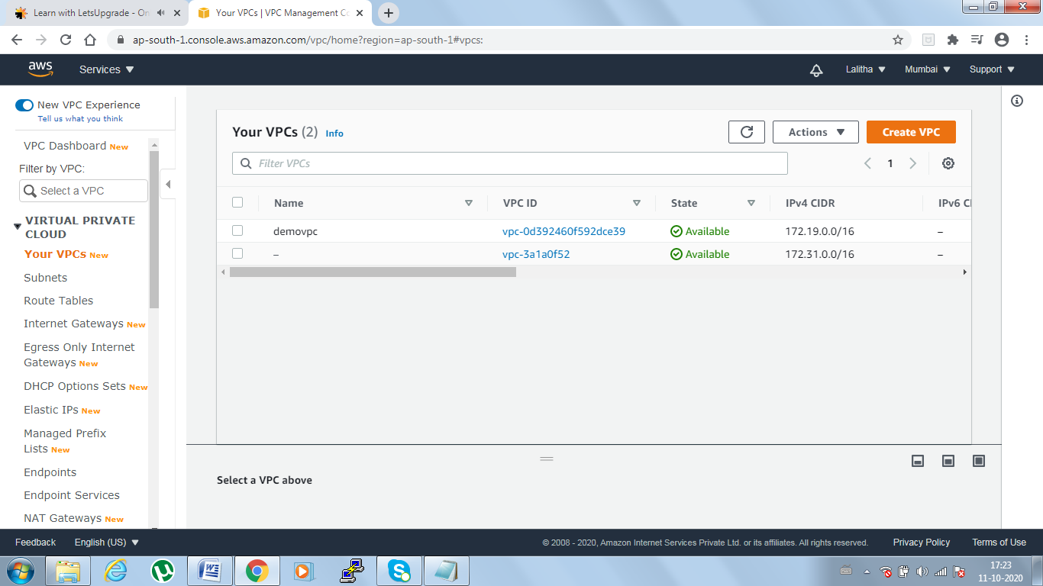  
Step2: Access to the internet for which we need Gateway i.e internet gateway(IGW) i.e public for which VPC can be communicated

VPC-> Internet Gateway:Create Internet gateway ->Name tag(demoIGW)-> click on create IG  
IGW Page-> select demoigw created->Actions -> Attach to VPC

->Available VPC (u will get available VPC)-> click on attach IGW  
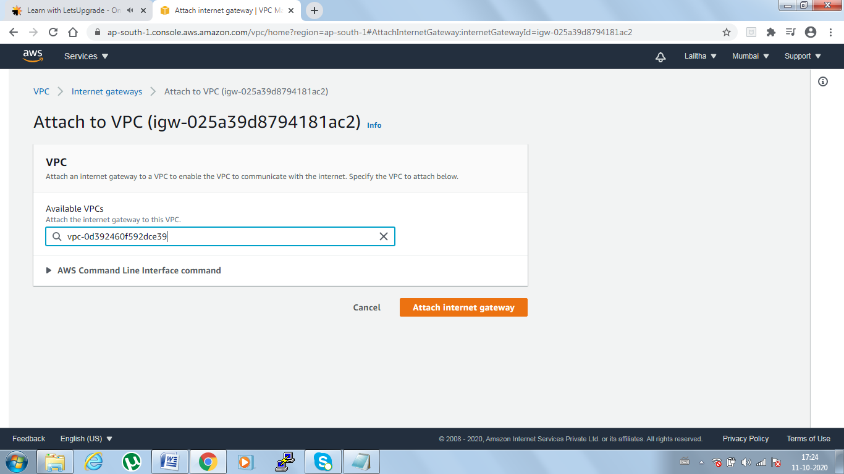

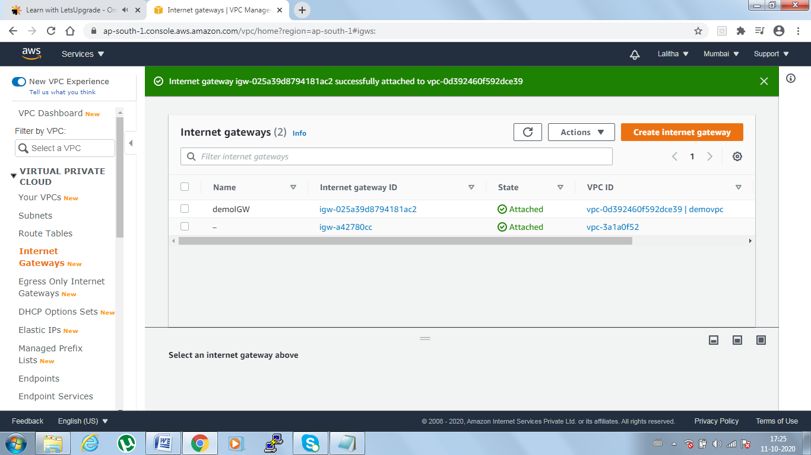

Step3: Create a Route table

VPC -> Route tables-> Create route table-> Name tag(demoroute)->under vpc select demovpc which we created-> click on create-> close

select demo route->Actions->Edit routes->our ip will come->Add route(0.0.0.0/0)->Target(our igw select)-> save routes->After success message close it

select demo route-> Actions-> set as main route table->ok

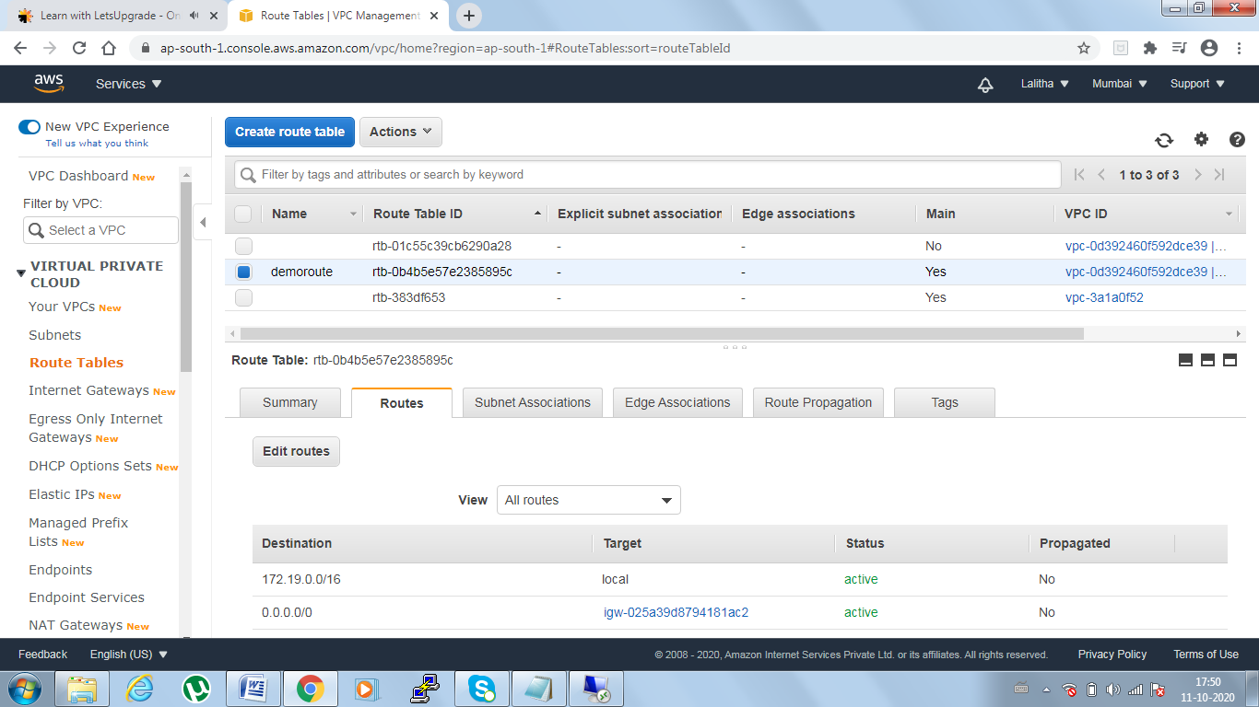

Task4 :Create Subnet VPC->Subnets->create subnite->name tag(demosubnte1)->VPC select (demovpc)->AZ (no pref)->ipv4 ccidr(172.19.19.0/24)->Click on create

select subnet created->Actions->Modify auto-assign IP settings -> Auto-assign IPV4(enable)-> save

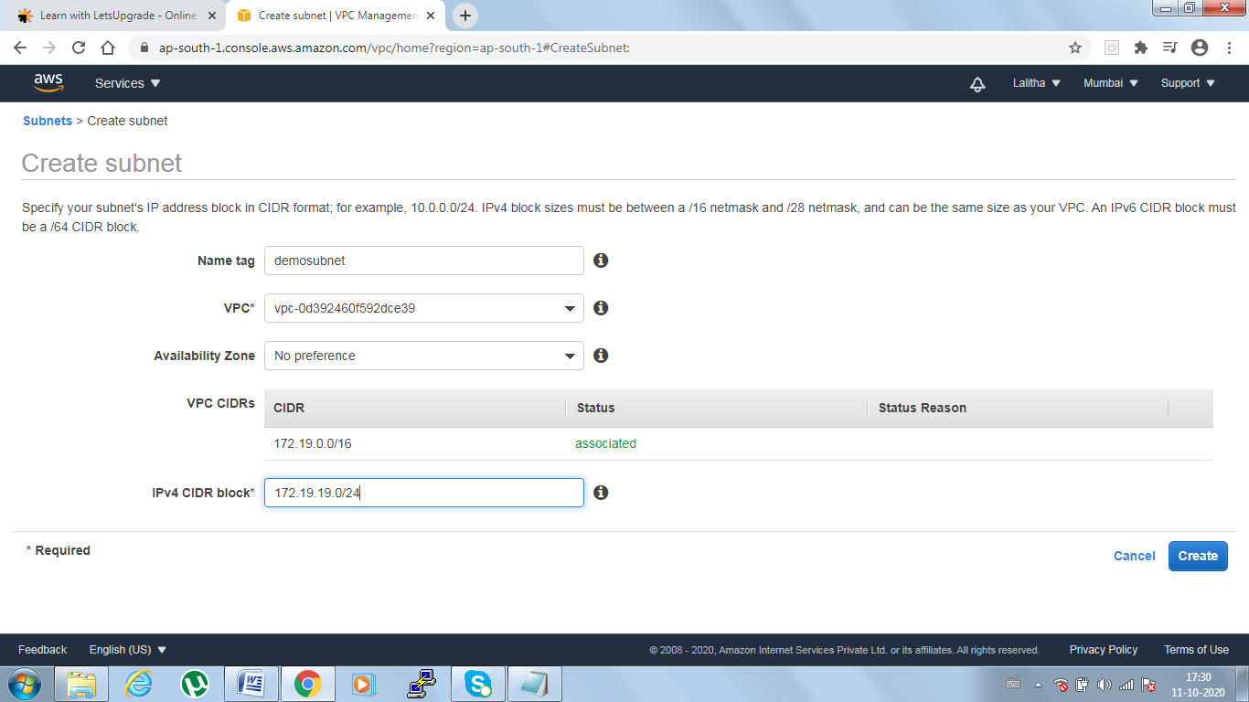

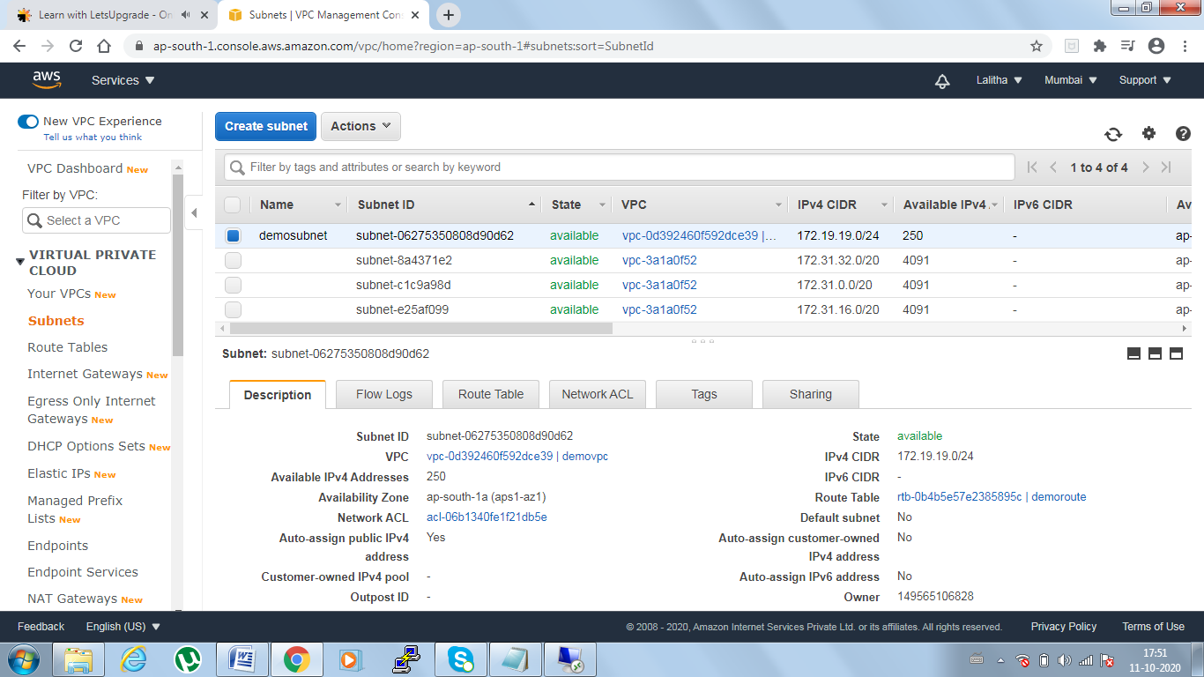

Task5 : Create an EC2 instance with custom VPC  
Config details->Network->select demovpc->subnet(our subnte)->Enalbe auto assign public ip

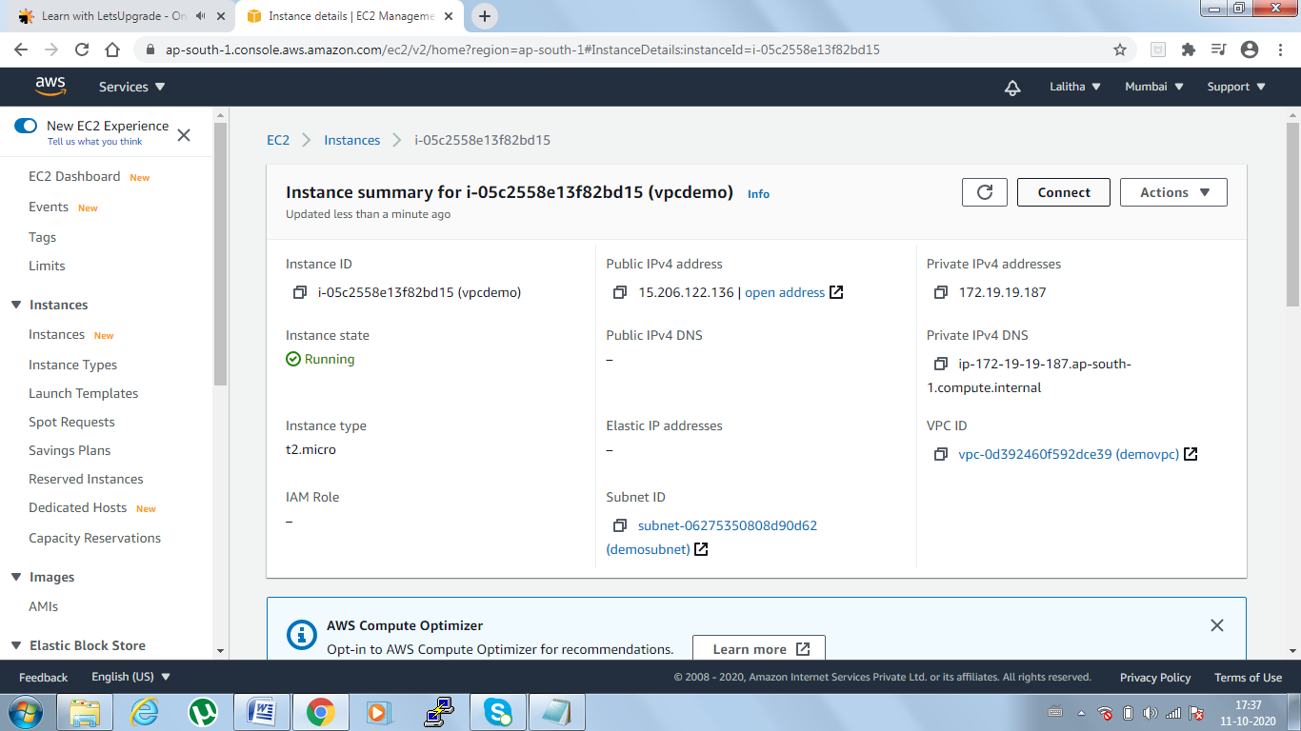

Task6: Checking the IP Config in VM command prompt

